Internationalisation EEP 2018-2019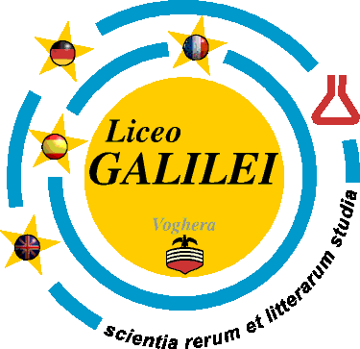
- You still haven’t participated in an internationalization project and want to do so before you leave school? Well this might be your opportunity!

- We are looking for a small group of enthusiastic and creative fifth formers who want to participate in this year’s EEP project

- The EEP is the European Educational Project with the Liceo Scientifico in Voghera (Galileo Galilei). It focusses on the livability of the city we inhabit and studies social and environmental problems, using sustainable means to try to solve them.

- Activities to sort out the livability consist of doing research, interviewing, presenting and debating.

- The programme will also contain social and cultural items

- The project runs for one year from November 2018 till April 2019

- The selection will take place in week 46 – we will invite some students in that week to introduce themselves to us as we don’t know any of the Athena students yet!

- The first exchange takes place in week 6 in February during which time we will gain an understanding of sustainability as well as improve our debating skills. After the first exchange we will continue our work and end with an exchange in Italy in week 16 (April) 2018

- You will host an Italian student and you will be hosted in return.

- The costs of the project will be 325 euros which can be paid in two parts: 225 euros should be paid in November – your parents will receive an invoice – the rest in cash in April.

- Work for EEP can be used for schoolwork: e.g. PWS, preparation for English exams and Practical assignments

- An application letter needs to be written in English, specifying personal details as well as motivation – we are very much interested in how you think you can contribute to the project being successful!

- The deadline for sending your application letter is 3 November. The letter has to be sent by e-mail to a.reichart@gymnasiumleiden.nl and k.vanwelzen@gymnasiumleiden.nl on or before 3 November

- The names of the selected students will be made public in week 46

- The new group will meet 20 November at Socrates - 7th & 8th period – we will specify the classroom on the 20th

- All meetings will be held at Socrates

- Questions about the EEP can be addressed to Ms Reichart or Mr van Welzen

