Internationalisation EEP 2019-2020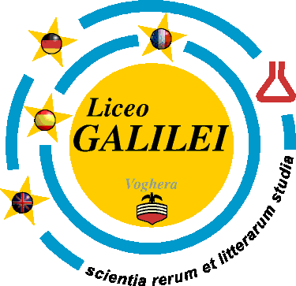
- You still haven’t participated in an internationalisation project and want to do so before you leave school? Well this might be your opportunity! EEP is the last internationalisation project on offer

- We are looking for a small group of enthusiastic and creative fourth formers who want to participate in next year’s EEP project

- The EEP is the European Educational Project with the Liceo Scientifico in Voghera (Galileo Galilei). It focusses on the livability of the city we inhabit and studies social and environmental problems, using sustainable means to try to solve them.

- Activities to sort out the livability consist of doing research, interviewing, presenting and debating.

- The programme will also contain social and cultural items

- The project runs for one year from September 2019 till March 2020 although the first meeting is in July, just after your testweek

- The selection will take place in week 26 – we might invite some students in that week to introduce themselves to us as we don’t know any of the Athena students yet!

- The first exchange takes place in week 45 in November during which time we will gain an understanding of sustainability as well as improve our debating skills. After the first exchange we will continue our work and end with an exchange in Italy in week 11/12 (March) 2020

- You will host an Italian student and you will be hosted in return.

- The costs of the project will be about 350 euros which can be paid in two parts: 225 euros should be paid in August – your parents will receive an invoice – the rest in February. We will try to reduce the costs, but the total cannot be determined until the flight has been booked.

- Work for EEP can be used for schoolwork: e.g. PWS, preparation for English exams and Practical assignments

- An application letter needs to be written in English, specifying personal details as well as motivation – we are very much interested in how you think you can contribute to the project being successful!

- The deadline for sending your application letter is 26 June. The letter has to be sent by e-mail to a.reichart@gymnasiumleiden.nl and k.vanwelzen@gymnasiumleiden.nl on or before 26 June

- The names of the selected students will be made public in week 28

- The new group will meet 11 July at Socrates - lunchtime – we will specify the classroom on the 11th

- All meetings will be held at Socrates

- Questions about the EEP can be addressed to Ms Reichart or Mr van Welzen

